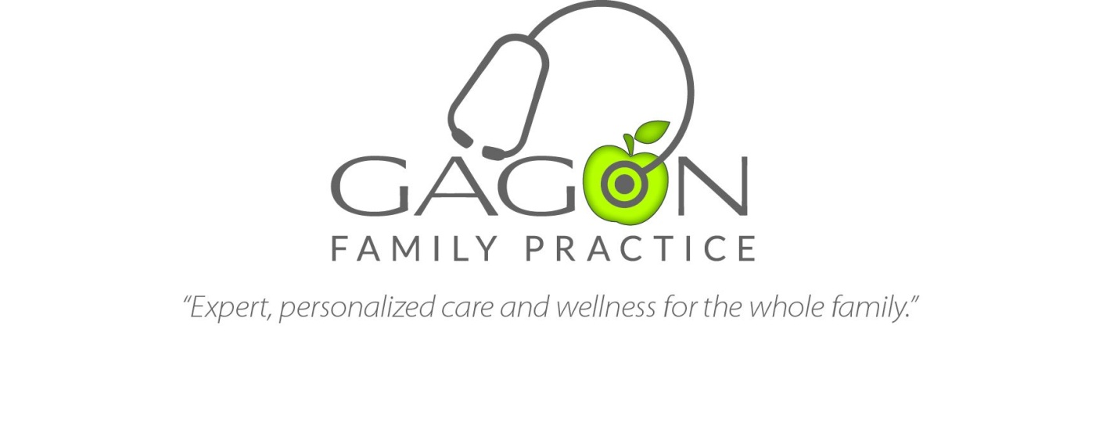
Physician Assistant or Nurse Practitioner

Summary:
Gagon Family Practice is hiring a full-time certified physician assistant or nurse practitioner to join our busy family medicine clinic in Price, Utah. The ideal candidate will have a personal drive for clinical excellence and work effectively in a team environment. Candidates with a special interest in women’s health and/or pediatrics are especially encouraged to apply.
The successful candidate will be responsible for providing exceptional outpatient care in an appropriate, effective, timely and cost-efficient manner. He or she will also be responsible for all aspects of patient assessment, diagnosis, and determining an appropriate plan of care in consultation with Dr. Gagon.

Basic Qualifications:
- Graduate of an accredited program
- Current Utah state license
- Current Utah state Controlled Substance License
- Current Federal DEA Certificate
- Background check

Application Process:
To apply, interested applicants should send a current CV and three letters of recommendation to ginagagon@gagonfamilypractice.com. We will consider 2015 graduates.

