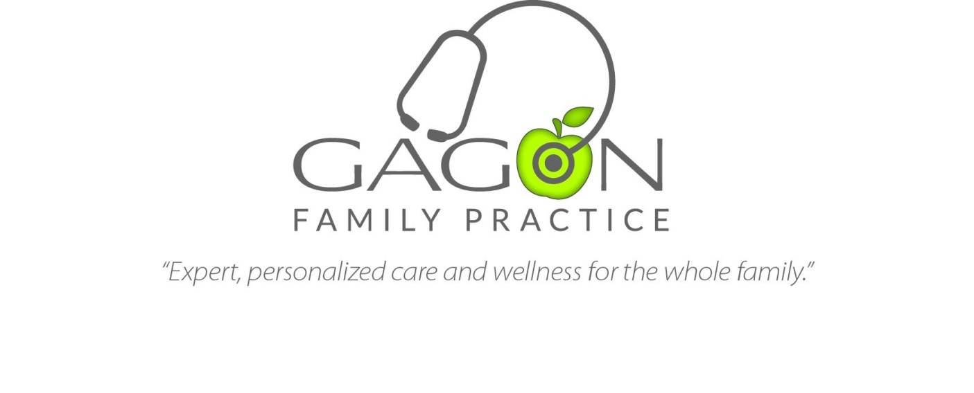
Medical Receptionist

Summary:
This is a full-time position responsible for scheduling patient appointments, obtaining accurate registration and billing information from patients, and collecting patient payments.

Basic Qualifications:
- Ability to multitask effectively, managing phone calls, in-office patients, staff and others pleasantly
- Ability to communicate calmly and clearly with patients
- Ability to analyze situations and respond appropriately
- High school diploma
- Background check

Application Process:
For confidential consideration, please email resume to GinaGagon@GagonFamilyPractice.com

